

**G11**

**SENIOR HIGHSCHOOL**



**QUARTER 1 – Module 2**

**LESSON 2: ACADEMIC LANGUAGE**

**Name of Student**

**Strand/Year & Section**

**Prepared by: Reymart T. Metrillo**

*Subject Teacher*

**What is an Academic Language?**

Academic language represents the language demands of school (academics). Academic language includes language used in textbooks, in classrooms, on tests, and in each discipline. It is different in vocabulary and structure from the everyday spoken English of social interactions. Each type of communication (both academic and social) has its purpose, and neither is superior to the other.

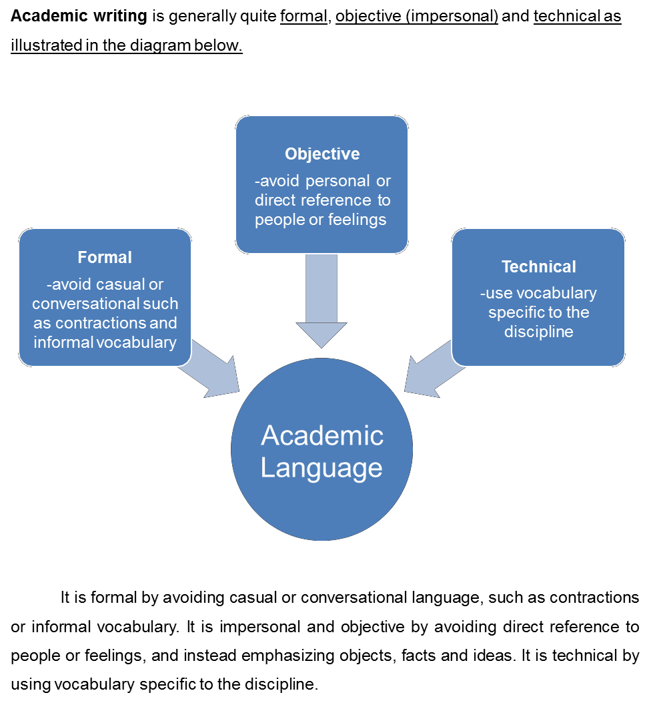

**Furthermore, you can make your writing more formal,**

**objective and technical by following examples below.**

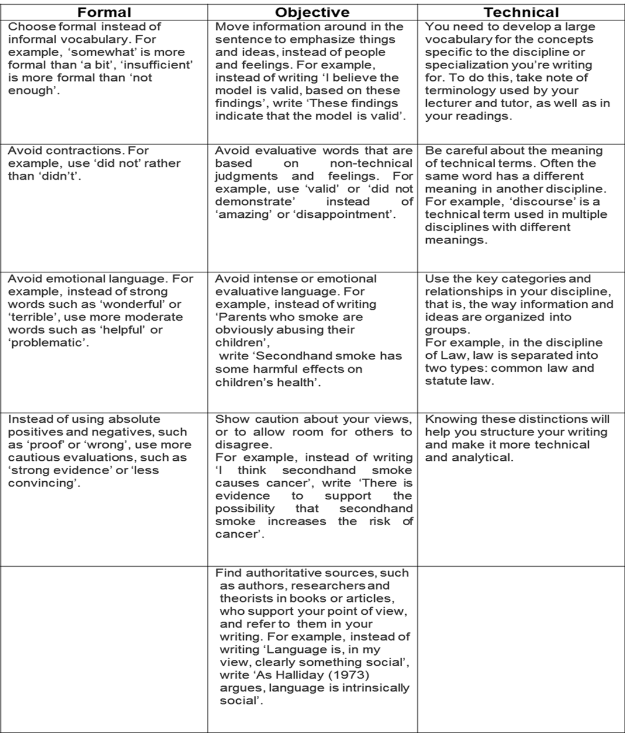

**QUIZ 2**

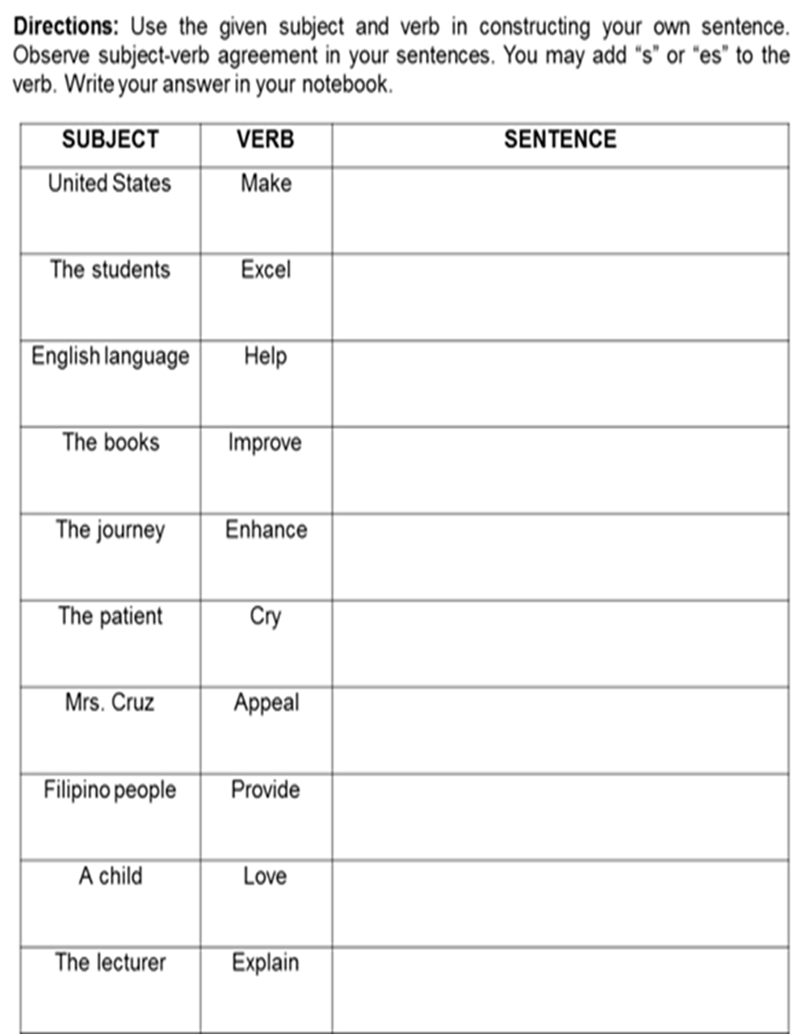

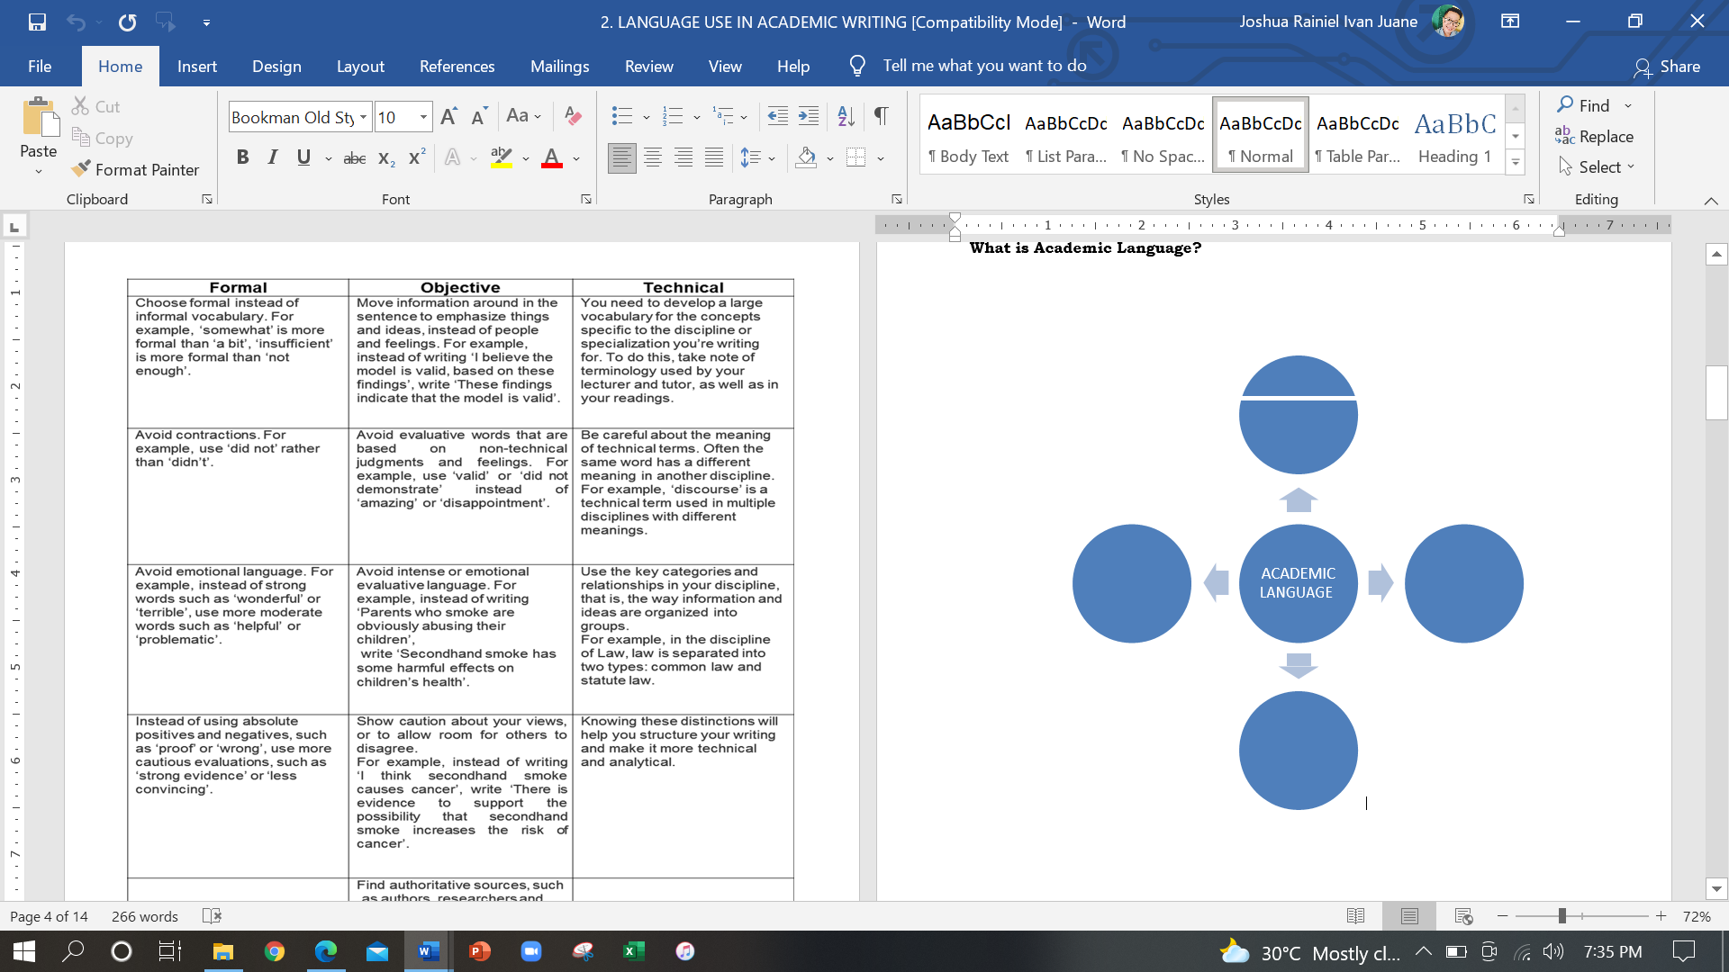**ACTIVITY 2 –** Below is a graphic organizer of idea. Give any related ideas about the main ideas in our graph below.